COMPLETING TRANSMITTALS
- Depending on what the order face asks, create PDF’s and STEP files in addition to the AutoCAD drawings if needed.
- Fill out Transmittal Word Document
(Form to be filled out when Debbie Decker is not on the clock)
- Change date
- Check Order# and P.O.
- Add correct emails (usually found on last page of order face)
- Check the correct box for approval or record only
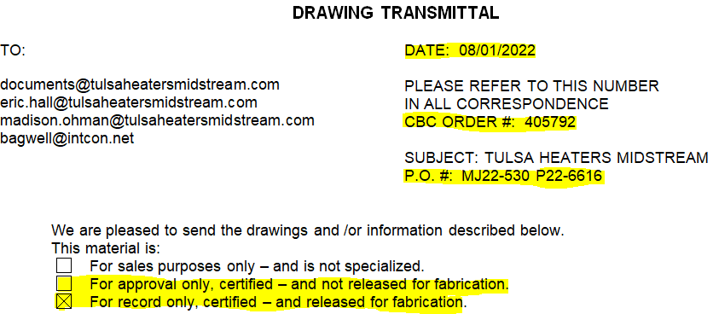

- Fill out titles of documents needed in “Drawing No.” column:
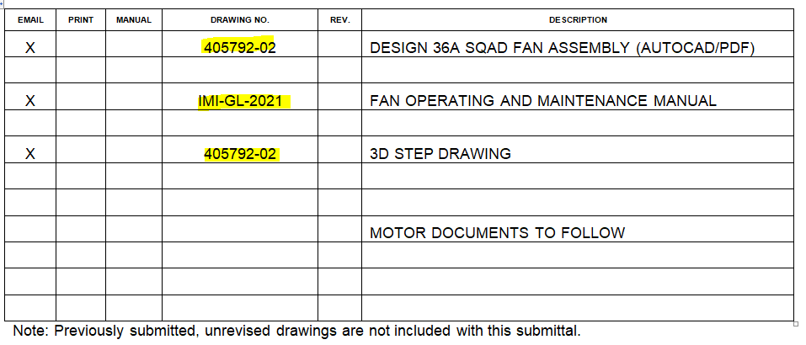
- Sign your initials at bottom of document

- Go to CBC Insider and hover over “Engineering” tab and select “Email Drawings”:
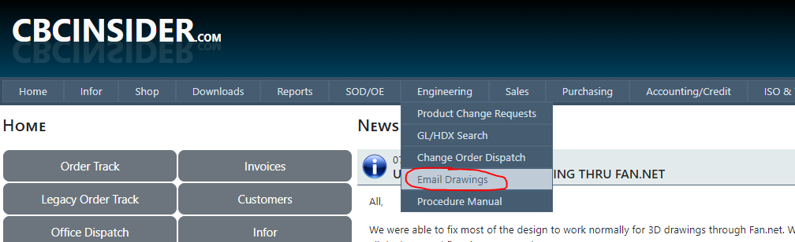
Enter in your Order#

- Insert emails from Transmittal Word document where each email is separated by ;

- Attach the files (including filled out Transmittal Word Document) that the customer wanted or what was filled out in the table from bullet point 3). After each selected file, click “ATTACH FILE” until you upload all desired files.

- You will receive an email where you copy the message and paste it in the Transmittal folder. Rename that copied email to the same name as the Transmittal document followed by -01. The numbers change in numerical order as required per Revisions:

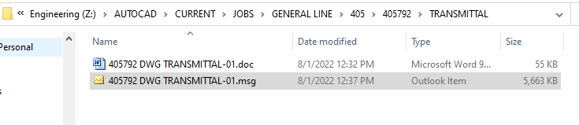

- Right click on the email and select “Send to IDM”
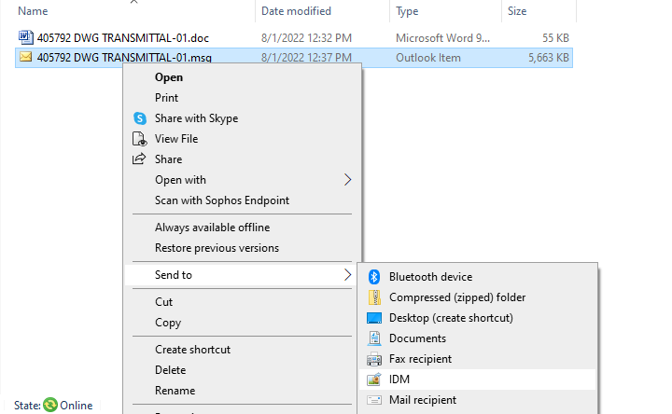

- The program will open up where for
Context: InforSalesOrder
Document Type: CBC_DrawingTransmital

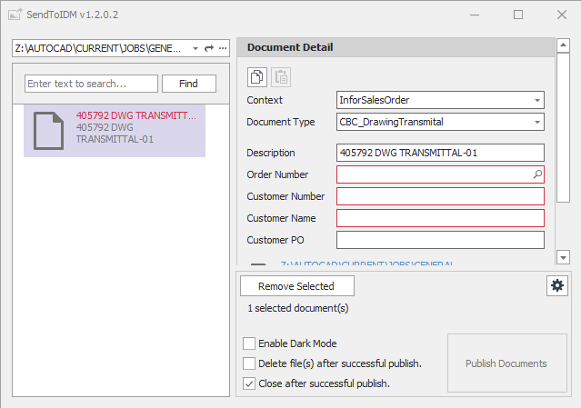

- For Order Number, type yours and click the magnifying glass. It’ll autofill the rest of the information for you.
- Click “Publish Documents” and close the program if the “Close after successful publish.” is not checked.
- Go into the Office Dispatch and click on your job number. Click “Clock In”, wait for it to load, then click “Clock Out & Complete.”

